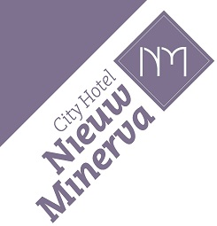
Reservation form

41st Annual EAIR
Forum 2019 Leiden

Rates:
Single room excluding breakfast: € 89,40 per night
Single room including breakfast: € 99,16 per night
Double room excluding breakfast: € 103,72 per night
Double room including breakfast: € 123,25 per night
Rates are including city tax.

Please fill in the following details:
Name guest:
Check-in date:
Check-out date:
Amount of persons:
Including or excluding breakfast:

Remarks/preferences:

Guarantee method
Credit card number:
Expiry date:

For your information:
- Your room is available from 14:00 h. In case you arrive early and your room is not ready yet, your luggage can be kept at reception. Our reception is open 24/7.
- In case the guest does not arrive, No-show costs will be charged.
- The Dutch Horeca Federation standard Conditions are applicable to all reservations.

Thank you for your reservation at City Hotel Nieuw Minerva.
For further questions please contact us.

With kind regards,
City Hotel Nieuw Minerva

Hotel Restaurant Nieuw Minerva b.v. | Boommarkt 23 | 2311 EA Leiden | T. +00 31 (0)71-5126358
F. +00 31 (0)71-5142674 | www.nieuwminerva.nl | E-mail: hotel@nieuwminerva.nl | K.v.K 28104097 | BTW nr. NL 814377993.B01

